|  | **Faculty of Information Technology**  **HUMAN COMPUTER INTERACTION**  **Spring 2022** |
| --- | --- |

**Part I. Answer the question**

1. What is interaction design?

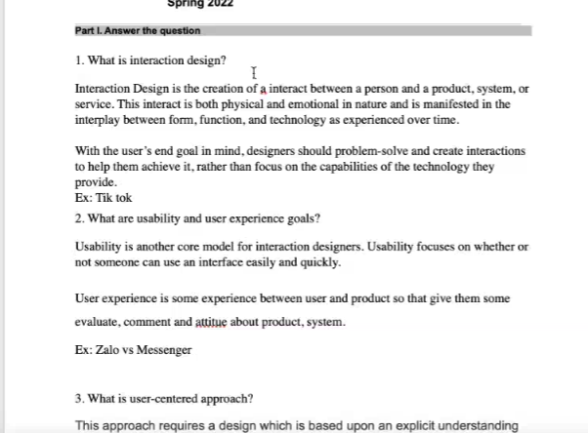

2. What are usability and user experience goals?

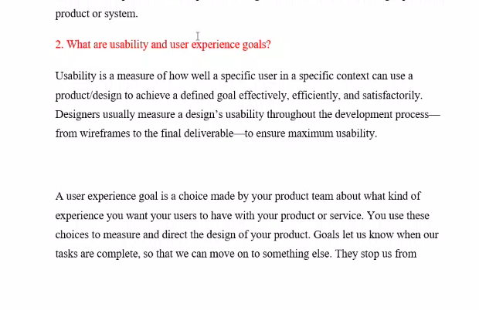

3. What is user-centered approach?

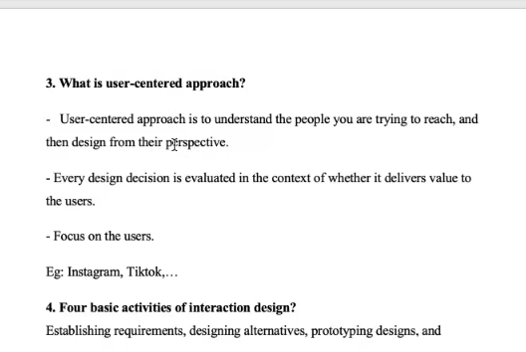

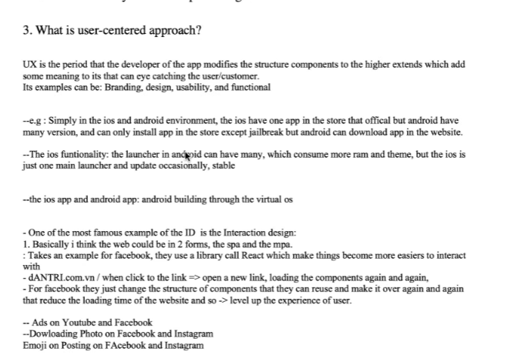

4. Four basic activities of interaction design?